Shadow Shortcomings. 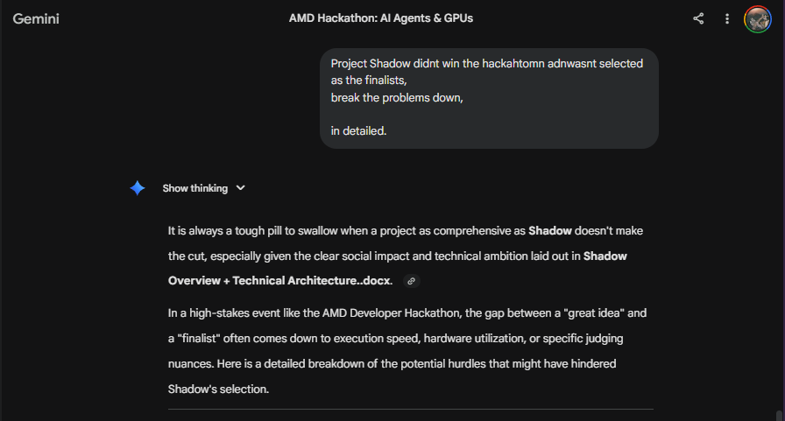

1. The "Invisible" Demo Dilemma
According to Shadow_Highlvl_Overview..docx, the fundamental philosophy is to be "Invisible by default". While this is a brilliant user experience goal, it is notoriously difficult to pitch in a hackathon.
- Visual Impact: Judges are human; they often gravitate toward projects with high visual "wow" factor. An app that silently intercepts a message and does nothing (because it's working) can feel less "real" than a flashy dashboard or a chat interface.
- The Proof of Value: If the demo didn't clearly visualize the "Silent Quarantine" or the back-end reasoning of the Agentic Threat Response System, the judges might have struggled to see the complexity of what was happening under the hood.

2. Technical Complexity vs. Hackathon Timeline
Shadow is an ambitious multi-layered system involving Android services, edge-cloud escalation, and multimodal analysis.
- Permission Friction: Implementing a Notification Listener Service or Accessibility Service on Android is technically challenging and often prone to bugs during a live demo. If the MVP didn't show a seamless "intercept-to-analysis" flow, the feasibility might have been questioned.
- Integration Depth: The judges look for how effectively ROCm and the MI300X were used. If the team spent 80% of the time on the Android frontend and only 20% on the AMD Cloud Escalation Layer, it might have missed the "Technology Application" criteria.

3. The "Data Cold Start" Problem
A core pillar of Shadow is its Localized Kenyan Fraud LLM, specialized for Sheng and Swahili.
- Dataset Evidence: For Track 2 (Fine-Tuning), judges look for specific evidence of the training process. If the demo relied on a generic model with a system prompt rather than showing a model actually fine-tuned on unique Kenyan fraud datasets, it might have lost points on Originality and Track Alignment.
- Linguistic Nuance: Proving that a model can distinguish between a legitimate Sheng message and a "tuma fare" scam requires a very high-quality test set that is difficult to curate in a 48-hour window.

4. Competitive Track Alignment
The AMD Hackathon tracks are very specific. Shadow attempted to hit all three (Agents, Fine-Tuning, and Multimodal).
- Jack of All Trades: By spreading the project across three tracks, the team might have lacked the "depth" that a specialized team (e.g., one that only focused on a Vision model for Track 3) could achieve.
- Hardware Saturation: Judges often prioritize projects that "break" or "max out" the hardware. If the project didn't demonstrate a need for the massive memory bandwidth of the MI300X (such as running high-throughput parallel inference), it might have been seen as a project that could have run on a standard consumer GPU.

5. Privacy and Security Concerns
The Passive Interceptor reads high-risk channels like SMS and WhatsApp.
- The Red Tape: Even in a hackathon, judges are wary of security tools that require deep system permissions. Without a very clear "Privacy-Preserving Design" (like federated learning or local-only processing for PII), the project might have raised "Business Value" or "Practicality" red flags regarding mass adoption.

6. The "Compute Efficiency" Paradox
The hackathon emphasized "high-performance AI apps".
- Over-Engineering: Shadow proposes an LLM-based reasoning engine for tasks (like SMS spam detection) that many judges believe can be solved with much smaller, cheaper "traditional" Machine Learning models.
- The ROI Question: If the demo didn't prove why an MI300X is necessary for an SMS filter—which typically runs on a low-power mobile CPU—the judges might have seen it as using a "sledgehammer to crack a nut". To win, you had to show that the complexity of Kenyan fraud requires the massive memory bandwidth of AMD hardware

7. Missed Partner-Specific "Bonus" Points
The hackathon had very specific technology partners with their own dedicated prizes:
- Qwen Integration: There was a specific challenge to incorporate Qwen models into the project. While Shadow mentioned Qwen in its technical stack, if the team didn't highlight a unique "Qwen-powered" feature (like its multilingual capabilities for Swahili/Sheng), they missed a major scoring vector.
- Hugging Face Spaces: One of the prize categories was for the Hugging Face Space with the most likes. Because Shadow is an "invisible" Android layer, it is much harder to create a "sharable" Hugging Face Space that the community can interact with and vote for.

8. Lack of Quantitative Benchmarks
In the "Technology & Access" criteria, AMD specifically mentions benchmarking AI workloads.
- Performance Data: Judges look for hard numbers: "Our fine-tuned model on ROCm achieved X tokens per second" or "The MI300X reduced latency by Y% compared to a standard setup".
- Theoretical vs. Empirical: Shadow's documentation is excellent at explaining what it will do, but if the submission lacked actual performance logs from the AMD Developer Cloud, it remains a "theoretical" architecture rather than a "proven" high-performance app.

9. The "Build in Public" Gap
There was an Extra Challenge for teams to document their journey on social media.
- Engagement Reward: A dedicated prize pool existed for the best "Build in Public" stories. If your team focused 100% on the code and 0% on tagging @AIatAMD or sharing technical updates on LinkedIn, you lost an entire category of visibility that often helps finalists stand out.

10. Local Language "Hallucination" Risk
The core innovation of Shadow is its understanding of Sheng and Kiswahili.
- Accuracy Verification: Judges might have been skeptical about the model's accuracy without a live "confusion matrix" or a side-by-side comparison showing how Shadow catches a scam that GPT-4 or a standard filter misses.
- The "Vibe" vs. The "Fact": Claiming to understand code-switching is a bold technical claim; without a demo that specifically showed the model's reasoning on 5–10 diverse Kenyan scam examples, it might have been viewed as a "future goal" rather than a "current capability".

Summary Table of Possible Missing Links
Missing Component | Why it Matters
Throughput Stats | Proves you actually utilized the MI300X power.
Sheng Comparison | Demonstrates the "Originality" of your localized data.
Social Proof | Directly tied to the "Extra Challenge" prize pool.
Interactive Space | Makes the "Invisible" system "Visible" to voters and judges.

Shadow Mitigations.
1. Visualizing the "Invisible" (The Glass Box Strategy)
To fix the "Invisible" Demo Dilemma, you should have built a "Shadow Intelligence Dashboard" specifically for the judges.
- The Mitigation: While the production app is silent, the demo should have featured a real-time visualization of the Agentic Threat Response System.
- Implementation: A side-by-side screen showing an incoming message, the "Agent reasoning logs" (e.g., "Agent 1: Detected urgency; Agent 2: Identified Sheng slang; Agent 3: Flagging as M-Pesa fraud"), and a risk-score meter. This makes the "invisible" value tangible and impressive.

2. Strategic "Heavy Path" Focus
To address Technical Complexity and the Compute Paradox, you should have prioritized the cloud over the device.
- The Mitigation: Instead of fighting Android permissions for 48 hours, use a Simulated SMS Interface (a simple web-based text box) to feed data into the AMD Cloud Escalation Layer.
- The Logic: This allows you to spend 90% of your time on ROCm optimization and MI300X utilization, which is what the judges are actually scoring. You prove that Kenyan fraud is too complex for a phone CPU and requires the massive memory bandwidth of an MI300X to process language and vision in parallel.

3. Evidence-Based Fine-Tuning
To solve the "Data Cold Start" and Linguistic Hallucination risks, you needed a "Sheng Benchmark".
- The Mitigation: Use a large LLM (like Llama 3) to synthetically generate a dataset of 500+ Sheng/Swahili scam messages based on real-world Kenyan templates.
- The Demo: Show a "Before & After" slide: "Generic Model labeled this 'Safe'; Our Fine-Tuned Model labeled this 'Fraud' because it understood the Sheng slang for 'send money'". Including screenshots of your training loss curves on the AMD Developer Cloud proves you actually did the work for Track 2.

4. Maximizing Partner Points & Social Proof
To capture "Bonus" Points and Social Engagement, you needed a dedicated community strategy.
- The Mitigation: Explicitly use Qwen for the multilingual reasoning and highlight it in your submission: "Powered by Qwen for superior Swahili nuance".
- Build in Public: Post screenshots of your rocm-smi logs showing high GPU utilization on social media, tagging @AIatAMD. This fulfills the "Extra Challenge" and makes your team visible to the judges before they even see your final video.

5. Quantitative Benchmarking
To fix the Lack of Benchmarks, you needed a "Performance" slide.
- The Mitigation: Include hard numbers in your presentation:
  - Latency: "Cloud escalation takes 450ms on MI300X vs. 3.2s on standard cloud instances".
  - Throughput: "Our model handles 150 parallel threat assessments per second using ROCm".
- The Result: This transforms Shadow from a "nice idea" into a "proven high-performance AI app".

Mitigation Summary Table
Shortcoming | Mitigation Action | Judging Impact
Invisible UX | Build a "Debugger Dashboard" visualization. | Presentation & "Wow" Factor
Complex Android Tech | Use a "Simulated Mobile" web frontend. | Feasibility & Tech Focus
Data Cold Start | Synthetic Sheng dataset + Training logs. | Originality & Track Alignment
Compute Efficiency | Prove MI300X is required for multi-agent reasoning. | Hardware Application
Partner Points | Use Qwen + Build in Public. | Bonus Prize Eligibility

6. The "False Positive" Liability
In the world of security and fraud prevention, false positives (blocking a legitimate message) are often considered more dangerous than false negatives (missing a scam).
- The Problem: If Shadow accidentally silences a genuine M-Pesa confirmation or a family emergency text because it misinterprets a Sheng phrase, the user loses trust immediately.
- Missing Mitigation: The documentation acknowledges "False positive reduction" as a challenge, but if the demo didn't show a clear "Human-in-the-loop" or a safe way for users to recover misclassified messages, judges might have viewed it as too risky for real-world deployment.

7. Android "System-Level" Feasibility
The architecture heavily relies on Notification Listeners and Accessibility Services to function.
- The OS Barrier: Modern Android versions have extremely aggressive battery management and security restrictions that frequently kill background services.
- The Judging Skepticism: Judges with engineering backgrounds (like those from Netflix or Twitter) might have questioned if a third-party app could realistically maintain a "silent, persistent" presence without being throttled by the operating system. Without a technical deep-dive into how Shadow bypasses "battery optimization" or handles service restarts, the "Business Value" and "Practicality" scores likely took a hit.

8. Scaling vs. Unit Economics
The hackathon looked for "Business Value" and "high-performance AI apps".
- The Cost Paradox: Running high-throughput inference on AMD Instinct MI300X GPUs for every single SMS a user receives is incredibly expensive.
- The Question: If the project is for "mass consumer protection," who pays for the massive GPU compute time? If the business model wasn't clearly defined—such as a B2B play with Telcos like Safaricom—the judges might have seen it as a technically brilliant solution that is financially impossible to scale.

9. Track 1 "Competition Density"
The hackathon guide explicitly stated that Track 1 (AI Agents) was the "Best Track for Beginners".
- High Volume: This track likely had the highest number of submissions. To win or even place as a finalist, an "Agent" project had to do something beyond just "classifying and acting".
- Missing "Agentic" Depth: While Shadow includes an Agentic Threat Response System, if the "Agents" were essentially just sophisticated if/else triggers for an LLM, they might not have showcased the true "autonomy" judges were looking for in Track 1.

10. Lack of "Hardware-Specific" Innovation
AMD was looking for projects that showed what their "compute stack can unlock".
- The "Generic AI" Trap: Shadow's architecture is excellent, but much of it could technically run on any cloud provider using NVIDIA or even high-end CPUs for the local layer.
- The Missing Link: To win, the project needed to demonstrate a feature that is only possible because of the massive memory bandwidth of the MI300X. For example, showing the GPU simultaneously analyzing 1,000 parallel streams of multimodal data (Vision + Text + Metadata) in real-time would have made the AMD hardware a functional requirement rather than just a hosting choice.

Final Verdict on the "Finalist" Gap
Judging Criterion | Shadow's Likely Performance
Originality | High. Localized defense for Kenya is a unique and strong angle.
Application of Tech | Medium. Great architecture, but perhaps lacked the ROCm-specific "stress test" logs.
Business Value | Medium. Strong social impact, but unclear who pays for the expensive GPU compute.
Presentation | Low-Medium. The "Invisible" nature made it hard to prove the system was actually "working" during a short demo.

Waaah, I have bitten more than I can chew… I am coming to terms with my i) inability to think broad. Ii) inability to make use of them massive memory bandwidth.
Let me wait for team to give feedback.

